Registration Admin Application
User's Reference

Table of Contents

Introduction 2
Property Lists 3
AddIns 5
Validation Rules 8
Submit changes in Database 10

Introduction

The Application Manager is designed for administrators to manage the XML configuration file for CoeRegistration graphically. This XML file contains information that customizes some CoeRegistration features for a specified customer: the database fields we want to have for a Compound, BatchComponent and Batch tables, their server validations in the application, and the AddIns that we want to run in certain events of the application’s life cycle. In order to manage these three functions more easily, the application has been separated into three tabs:
- Property Lists: It allows administrator users to view, add and remove customized properties.
- AddIns: It allows administrator users to view, add and remove custom handlers to certain events of the CoeRegistration’s life cycle.
- Validation Rules: It allows administrator users to view, add and remove custom validations on the data entered in each customized property.

All changes made in the application are reflected in the Xml column of the database table named CoeObjectConfig. To view the contents of the configuration file, we can do a SELECT statement from SQL*Plus (or your favorite sql tool), as can be observed in the picture:

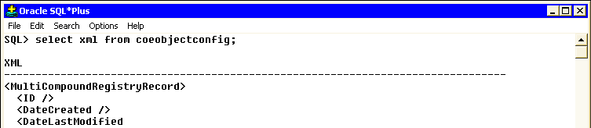

Property Lists

The first tab allows to manage customizable property using three tabs: Batch, BatchComponent and Compound. These tabs match to a table in the regdb schema that can be customized.

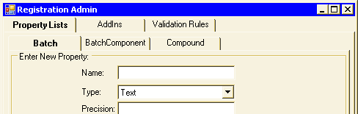

These properties have their corresponding columns in the underlying database table. For example, for Batch, we can see the columns in the database with a DESCRIBE statement against VW_Batch view, as shown in the following figure:

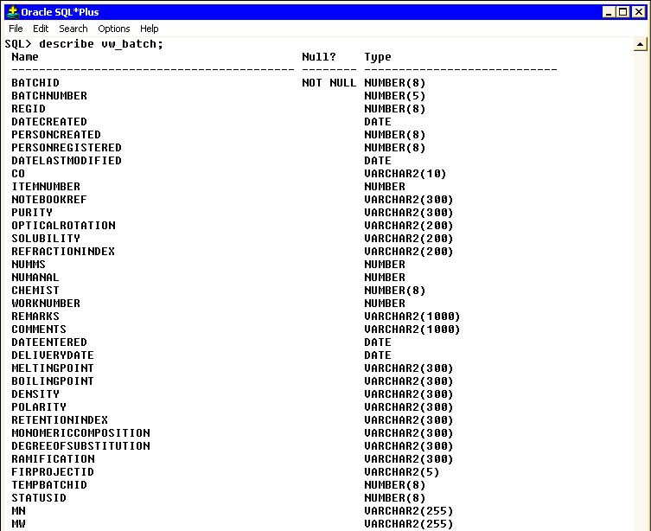

The application allows us to add custom properties for each table. To do this, just type the desired name of the property, choose the data type and set the precision for the column to be created in the database and click on the Add Property button. If the type chosen is “Text”, the field precision is not required to create a new property. If this value is not completed, it would use the default length precision of 1000 characters.

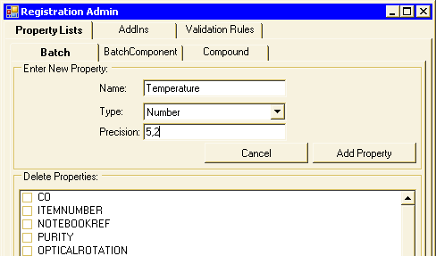

To remove one or more properties, we must check on the list those properties we want to delete and then click on the Delete Properties button.

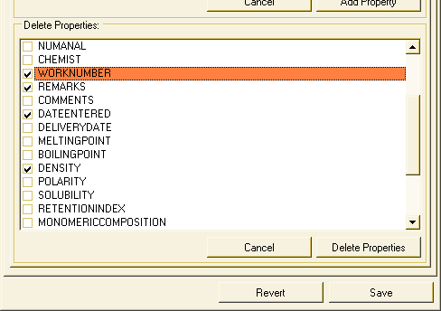

AddIns

The second tab displays a tree with a list of AddIns configured currently. These AddIns are custom procedures called by the events they were configured for.
To add a list of event handlers (the methods where the custom procedures are implemented), we must select the DLL library that contains the procedures to handle these events. For this, we can write the file name with its full path on the text box or click on the ”Library…” button and select one via a standard file browser.

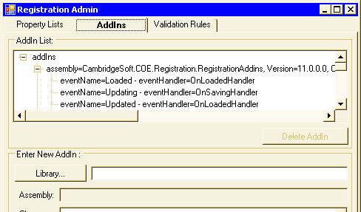

The library must have at least one class implementing the interface CambridgeSoft.COE.Registration.RegistrationAddIns.IAddIn to be usable.

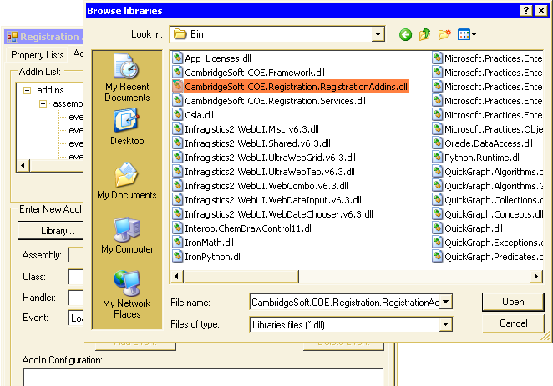

Once the library for the AddIn has been selected, the application allows us to select a class of the library and handlers. Click on the Add Event button to add at AddIn the list of events for each of the handlers. Also, with the Delete Event button, we can remove an added event in the list.

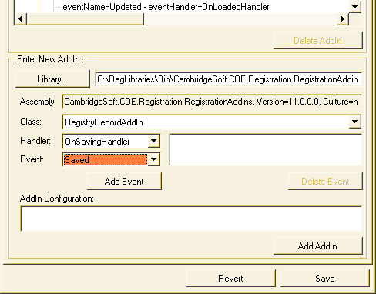

Finally, we can add text values for the AddIn configuration. This value is generally formed with XML tags so that the application validates that the value entered is valid text or XML.
After completing the data, we can add the new AddIn to the list with the Add AddIn button.

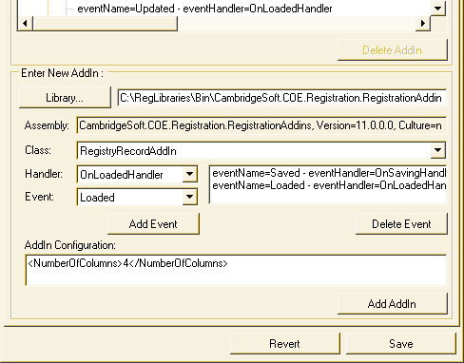

We can also delete an Addin, selecting the Addin that we want to remove and click on the Delete AddIn button.

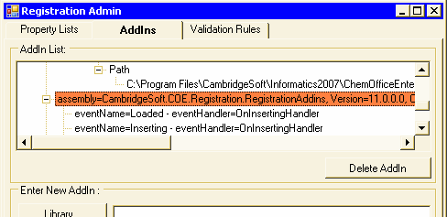
Validation Rules

The third tab displays a tree with the list of properties and their associated custom validations. If you click on the validation rule list of a property or on the property if we do not have a validation rule list, the buttons should be enabled to add custom validations to the properties.

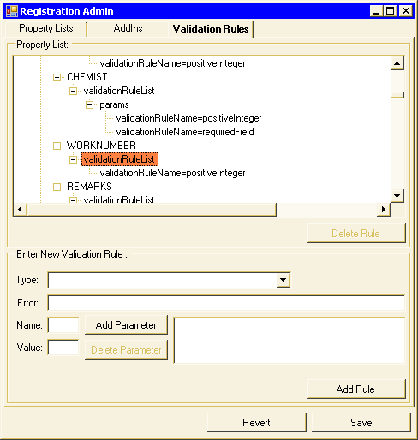

To add a new validation, we must choose the type of validation and add to a list of parameters of the same, if it has parameters. To add parameters, we must write the parameter name and value and click on the Add Parameter button. With the Delete Parameter button, we can delete a selected parameter of the list. We can also place an error message to the user if the data is not valid.

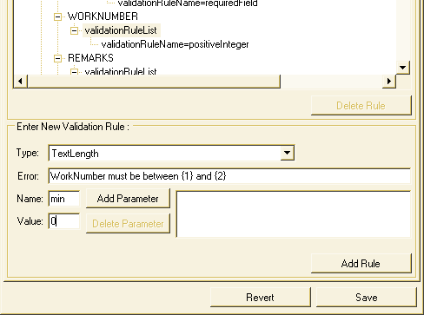

After completing the data, click on the Add Rule button.

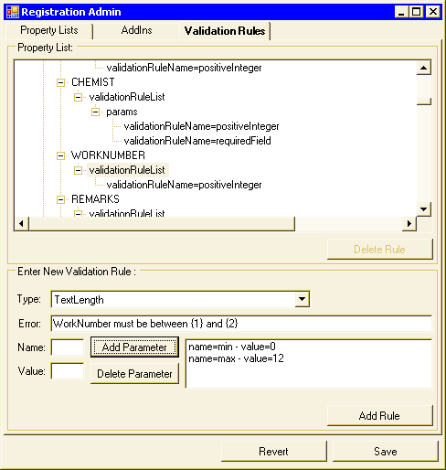

It is also possible to remove a rule validation. Selecting the desired rule validation will enable the Delete Rule button.

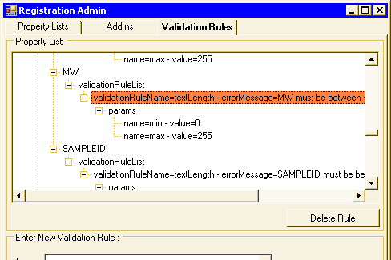
Submit changes in Database

Once the desired changes are completed on the configuration file, we can submit them by clicking on the Save button. This will change the XML file and will create or delete fields in the database from changes made in the first of the tabs.

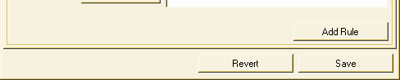

To reload the data displayed by each of the lists of those which had the file before the changes made, click on the Revert button.

